What is the difference between cloning and forking a repository in GitHub?

The difference is that forking a repository just copies whatever branch you want independently to your own new repository without the worry of commits and merging to the initial repository; basically, for if you just want to work alone and play with the code without the worries. Cloning on the other hand is a direct clone of the repository that is synchronize with the repository; cloning is usually for other team members to work on the same project at the same time.

How to Fork:

Just go to whatever repository you want to fork and click fork in the top right corner…

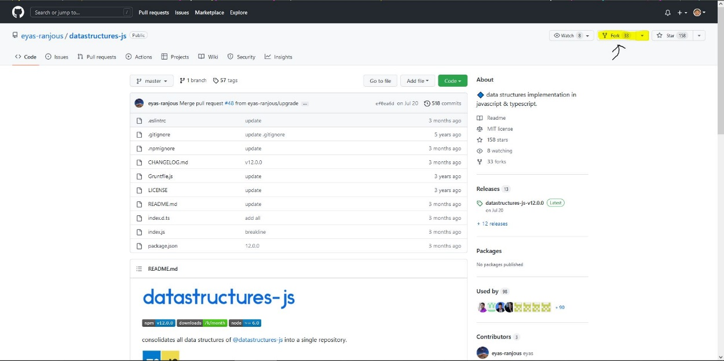

Then create your fork…

